Coursework 3 – Single Page Web Application Project Proposal

I am proposing to attempt to create a web application that will act as a collection tracker for Magic: The Gathering (https://en.wikipedia.org/wiki/Magic:_The_Gathering). This is a popular collectible/trading card game (I could go on for pages and pages about the game). Players of the game like myself tend to acquire lots of cards and as the number you own increases it becomes harder to remember what you own and what you don’t own.

Website Functionality

The website will allow users to sign up and log in so that the site can link the cards being added to the right person. I’m fairly sure this isn’t in the mark scheme but I did it before, am confident I can do it and am not sure how else to differentiate between what could potentially be 2 people with almost identical collections.
It will contain a form that allows signed in users to input the name of a card that they own and the quantity of that card that they own. That card gets added to the database.
Finally, it will contain a section at the bottom where all the cards in the collection of the logged in user can be viewed in detail and sorted.
I have a personal desire to add a specific search query to this but I am not sure how easy that will be to implement.

Database Design

I have a table that will hold all pertinent information on cards that people have tried to put into the database as fetched via the Official MTG API (https://github.com/MagicTheGathering/mtg-sdk-javascript).
There are other SDKs but I’m forced to use JavaScript for this project.
I have confirmed by raw HTTP request that this API will work

This is done to speed up adding cards to peoples collections as if the card has already been added elsewhere to someone else’s collection in the database there is no need to call the third-party API which will no doubt have a call limit for users or something.
I also plan to have a User table, holding an ID, username, password, email and a boolean to show if they are logged in or not.

I plan to have one table for owned cards, essentially a collation of all users collections. Each tuple here will contain a unique id, the id of the card they own from the Card table, the quantity of the card and the id of the user who owns the card.
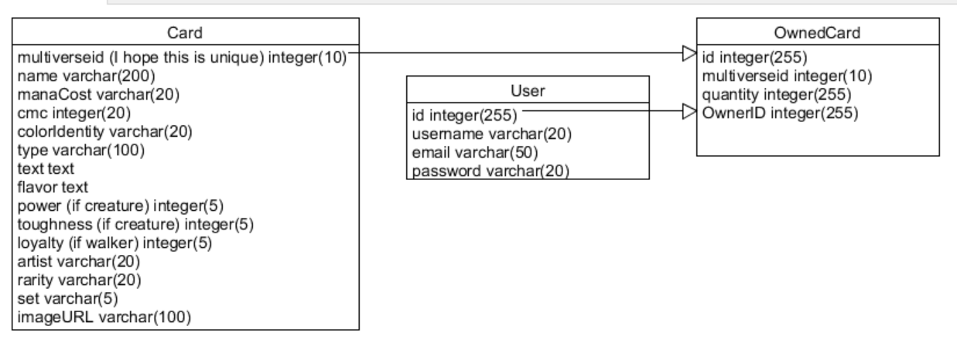

Website Wireframe
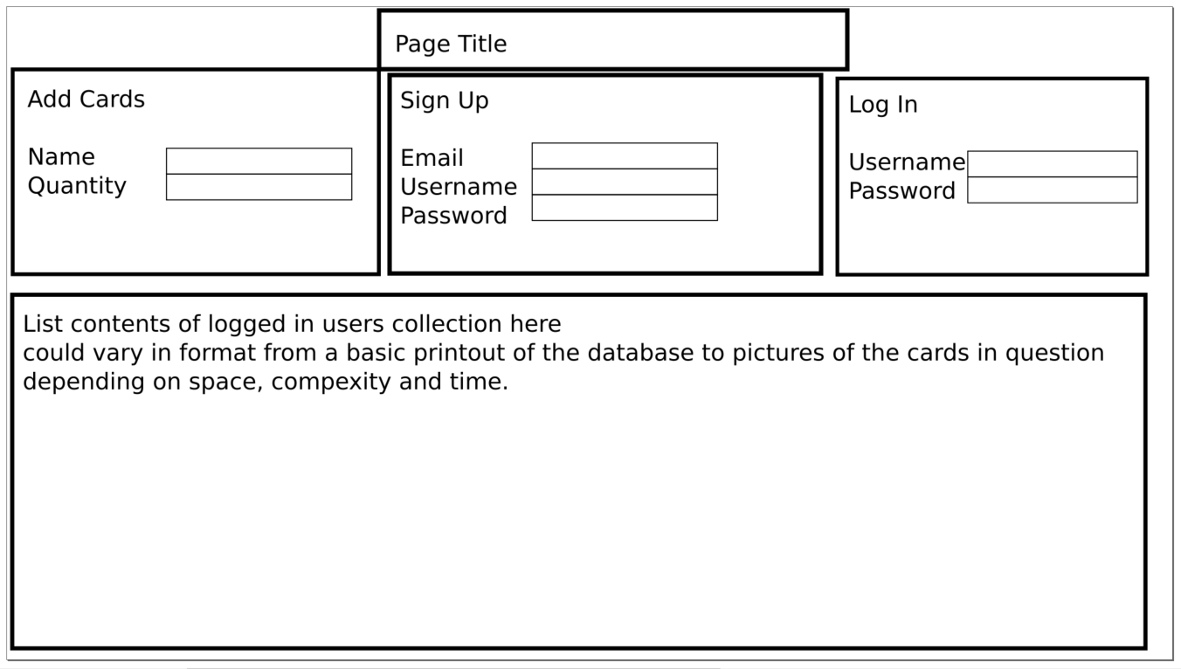
This is just my current concept for a UI, I’m not completely sure if it is the best design.
I anticipate it will change over the course of the project.
I might, for example need to add a search bar to the page somewhere to search users collections.

Extensions

- Adding a feature to see a picture of the card rather than the database entry
- Figuring out a way to remove cards. Currently, I see no issue in programming the server to accept {“name”: “card_name”, “quantity”: -1} in the absence of a dedicated function. You could literally say that the database quantity value = current quantity + JSON quantity value so 4 + -1 = 3.
- Adding a new table for decks of cards and the ability to move cards from your collection to a deck for clarity. A card someone owns is not necessarily available to go in a deck if its already in another deck. The challenge here is that decks usually contain a minimum of 60 cards and although duplicate cards are allowed, its not mandatory. A deck could conceivably contain 60 unique cards. A record for this would need 62 attributes, one for each card, one for the ID and one for the user ID.
That does not sound sensible.

